Software Installation Plan
Perfect Policies
Contains the relevant installation plans, methods, tasks, and all other related deployment necessities related to the Perfect Policies Project.
Oktay Turdu
05/06/2022

Table of Contents
Introduction 2
Objectives 3
Installation Method 4
Checklist – Server System Requirements 6
Checklist – Client System Requirements 6
Checklist – Security and Organisational Requirements 6
Checklist – Pre-installation Tasks and Resource Requirements 6
Data Requirements 6
Installation Procedure – Application and Database 7
Post-Installation Tasks 30
Uninstallation Procedure 36
Sign-Off 38

Introduction
The client Perfect Policies intends to transfer their paper test creating business into a digital test creating business. Recently, Perfect Policies has stated that they cannot set up a server system on-site and require hosting on the cloud for the application. They have indicated that they already have a small administrative application hosted on Azure, consequently resulting in them requesting the new application to be hosted in the same familiar environment.
Initially the client is happy with the database and back-end hosted in the cloud, allowing them to use a local version of the front-end of the application. However, their long-term goal is to have the entire application, including the front-end, to be hosted on the cloud and accessible world-wide on multiple devices. For this project, the back end and database will be hosted on the cloud. As a part of development and deployment, the client will provide their Azure account details on request.
The client’s budget for Azure is a maximum of $30/month, however, if costs exceed this, discussion can be conducted to explore further options. The client also intends to expand their cloud offerings in the future; therefore, they want the connection between the API and Database to be secure and of the highest security standards. The client has also provided sample data that is to be included during deployment to showcase the application to potential requirements.
In terms of documentation maintenance, the following will be applicable:
The Project documentation will be updated periodically after each version revision. Constant communication between the developer and project manager will be maintained to ensure documentation is accurate and is of the highest standard for each version. During development, if the business case scenario differs in any way, with constant communication between the stakeholders, the project documentation will be updated to reflect this.
In terms of versioning the application, version 1.0 will contain all the functionalities specified in the business case scenario, whilst containing only minor bugs. The letter abbreviations of ‘a’ for alpha, which means the first version of this build version that contains a substantial number of minor bugs, ‘b’ for beta which means the second version of this build version which contains a few minor bugs, and ‘s’ for stable where this will be the final release for this particular version. Minor version steps, where for example the application will be updated from 1.0 to 1.1, will only occur when a small feature is added to the application, however, the core functionality of the application and any base visual elements will not change. This minor versioning step may occur when the client requests a small feature to be implemented at a later date. Major versioning steps, where an application may be updated from 1.0 to 2.0, will only occur when a total overhaul or several substantial features are added to the application, whilst maintaining other functionalities present in previous versions. This major versioning step may occur when the client may request a feature that results in a new project with a business case scenario that differs substantially from the initial scenario. Documentation versioning will reflect the application, however, for small fixes such as spelling or grammar, the documentation will be updated in the following manner:
Documentation v1.0 to Documentation v1.01
Project documentation will be stored securely at a standard specified by local legislation. Any project documentation requested by the client will also be stored in the same manner. Delivery methods for the application and the documentation will occur in secure but easily accessible channels, such as providing an encrypted file to download with a password provided by the project manager. This file will be sent by email and stored into a password protected cloud network to be accessed later by both the client and the project manager.
The naming convention for projects will be in the following manner:
[Project Name]_[Client]_[Date(dd/mm/yyyy)]_[Version]
In the above example, the project name will contain the project’s full name as specified by the project manager, the client will be the client’s full name as specified in the business case scenario, the date will be the saved date of the project documents, the version will be the version of project documents for that particular day. All current and future projects will follow this format.
In this project’s case, the format would be:
PerfectPolicies_Jeff_07112021_1
Another project that follows this format will be as follows:
BirthdayTracker_Caroline_05102021_1
For source code control and version control, Git and more specifically GitHub was utilized. Git is software developed by Linus Torvalds that allows the tracking of changes in files. GitHub is simply a hosting service for Git projects. The reason for using these technologies is that Git is the industry standard for collaboration and source code management whilst GitHub allows the free hosting of projects whilst incorporating Git related functionality alongside extra quality of life features such as visually managing a Git project from the website itself.

Objectives
The API and SQL database related to the application will be hosted in Azure. The application’s various functionalities related to data storage and the retrieval of data, such as single and multiple records for Quizzes, Questions, Options etc. will be able to be conducted the same through Azure as if it was conducted if the API and database was locally hosted. Alongside this the expected outcomes at the conclusion of installation are as follows:
- A developed Web API that connects to a back-end and is accessible by multiple users world-wide on multiple devices
- Secure connections between Azure processes, and between the API and database.
- Web API, Back-end service deployed to Azure alongside relevant database which is deployed to Azure SQL Server
- All elements of API, including endpoints and connections, are tested and accessible from a local machine
- Software Installation Plan that details all processes and functions, including a deployment process that allows for future expansion and iteration.
- All Azure related functionality’s running costs must stick to a budget of no more than $30/month

Installation Method
To install the application to the Development Environment the following process is applicable:
- Install Visual Studio 2019 and set up or utilize an Azure account and password. Log-in to Visual Studio with these Azure account details.
- To migrate a pre-existing database Microsoft SQL Server Management Studio must be downloaded. However, for deployment a pre-existing database isn’t essential as the SQL database will be created with Azure through Azure SQL Server, which is an intelligent database service that allows compatibility with modern cloud applications and operating systems, and pre-seed data will automatically seed to the database when the application is deployed.
- At this point the application code of the back end should be viewable from the IDE (Visual Studio).
To create the database to Azure the following process is applicable:
- Firstly, a sever must be created on the Azure portal with the user accounts provided or created. Navigate to the SQL Server page by searching it at the top of the page and Click Create.
- Configure the various configurations on all the tabs (Basics, Networking, Additional Settings, Tags). Refer to the in-depth Installation Procedure with screenshots for more details.
- Click the Review and Create Tab and review all the information to make sure it is correct.
- After the server is created navigate to its Firewalls and configure the IP details to allow access locally. Various configurations relating to the SQL elastic pool, compute and storage, and storage redundancy will need to be configured. Similar configuration processes will need to be conducted in the Networking and Security Tabs, alongside any other tabs related to the SQL Database. Refer to the in-depth Installation Procedure below for more details.
- After reviewing all the information entered, the SQL database should be created and will be viewable from the SQL databases page.
To deploy the API and migrate the database to Azure the following process is applicable:
- In Visual Studio open the API and navigate to the Build and Publish Menu. Select the target as Azure and select the specific targe as the Azure App Service.
- Login with the user details used for creating the database in Azure.
- Create an azure app service and select the resource group. Set the App Service plan to a free plan for the time being (this can be more reliably modified later through Azure directly).
- Select the App Service from the instance list and modify the target run time.
- Finally publish the API after turning off the connection string and migration settings under databases.
- Set up class and API context details in the configure method.
- Navigate back to Azure and set the connection string of the SQL server to the key from the API.
- Re-publish the API from Visual Studio and remove migration context methods the Configure method of the database in the source code before re-publishing the API a third and final time.
Refer to the in-depth Installation Procedure below for more details.
It is important to note that all settings must be set as applicable to the client’s security and budget requirements, which are outlined in the Objectives section of this document.

Checklist – Server System Requirements
As the client requested that all Azure functionalities must adhere to a budget requirement of no more than $30/month, the database server will be hosted on the Basic Tier which costs approximately $7.60/month and provides 2 gigabytes of included storage, 2 gigabytes max storage and 5 Database Transaction Units. Database Transaction Units are a propriety measuring standard utilized by Azure that gives an overall estimation of resources regarding the CPU, Memory, Data I/O, and Log I/O. The exact core counts and hardware specifications are unclear with Data Transfer Units, however, according to articles such as https://sqlperformance.com/2017/03/azure/what-the-heck-is-a-dtu, the basic tier consist of a less than or equal to one core CPU, and around 10 Input/Output operations per second. The API will be hosted on Azure’s free tier for the time being, which provides 60 minutes daily access, 1 gigabyte ram and storage. Azure provides flexibility regarding resources and these values can be adjusted later as resource needs grow. Configuration files, Dynamic Link Libraries, and System Environment Variables are handled during development.

Checklist – Client System Requirements
As all process are handled through the Azure cloud the client simply requires a device with internet access.

Checklist – Security and Organisational Requirements
A username and password must be created to access the application from Azure, however, the provided user details from the client can be applicable. These login privileges will be kept on record in accordance with privacy policies so that further improvements to the application can be made on request. Other related authentication privileges must be provided by the client post-installation, for fixing and maintenance related tasks.

Checklist – Pre-installation Tasks and Resource Requirements
The API should be run in Visual Studio in release mode to eliminate bugs and optimize code. Afterwards database related files such as the migration files need to be checked that they operate as intended. Correct communication between the API and database must be tested through several migrations. The XML installation process during deployment must be checked to ensure that the intended deployment process is followed. Server permissions must be provided by the client to ensure this is added when deployment commences.

Data Requirements
The data requirements relate to the deployed database which connects to the deployed API. Data in the database will be generated through the initial migration file created in Visual Studio by Entity Framework in ASP.NET prior to deployment. This file will be located in the Solutions Explorer in Visual Studio under the migrations folder. If the initial migration file does not exist, then one will have to be generated through the Package Manager Console through the command add-migration “Initial Migration”. This initial migration will contain all pre-populated default values and functionalities related to the database. Data transfers and general data requirements are small for an application of this size; therefore, they should not exceed the limits of Azure’s free tier for the time being. This limitation of data transfers can increase as usage increases, through applying Azure’s other tiers.

Installation Procedure – Application and Database
Firstly, navigate to the Microsoft Azure Portal and Sign in with relevant user details.
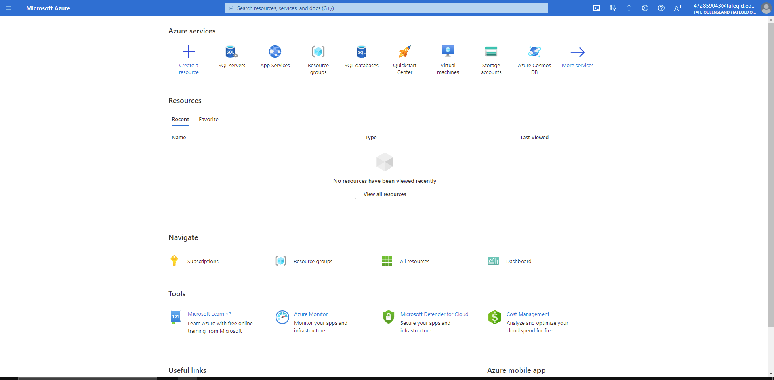
Afterwards, navigate to the Azure SQL Servers page by clicking on the More Services button, then Databases under Categories on the menu on the left-hand side of the screen, then SQL Servers from the menu that appears.
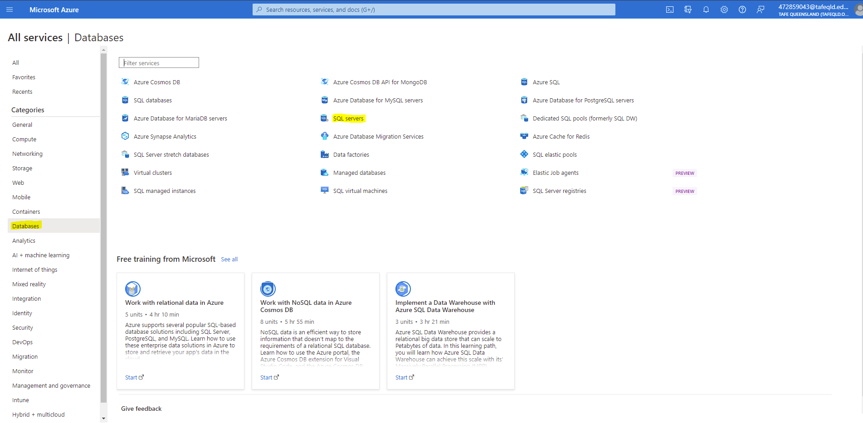
Create a new SQL Server by clicking the Create button at the top of the page under SQL Servers title. On the Basics tab, the following tasks must be completed:
- Subscription must be set to Azure for Students
- Resource Group must be selected or created by clicking the Create New Button and entering an appropriate name
- A Server name must be assigned with only lowercase letters and numbers.
- Afterwards the location must be set to (Asia Pacific) Australian East
- Assign SQL Authentication under Authentication Methods
- Assign Server Admin Login and Password Details provided by the client as follows:
  - Username: AdminPerfectPolicies
  - Password: PerfectPolicies!22

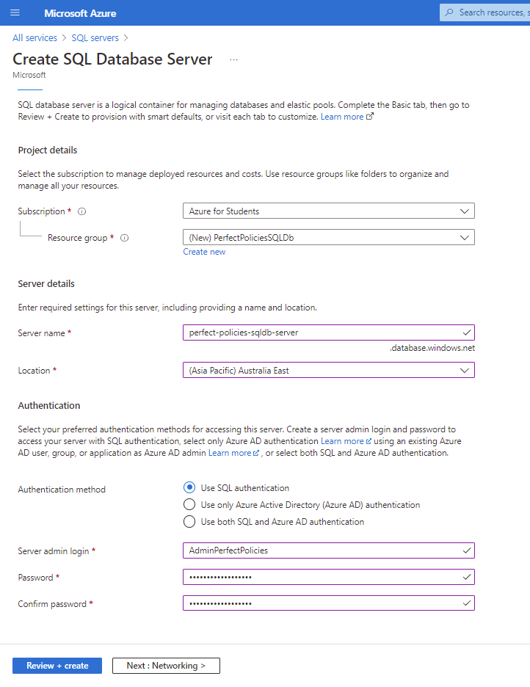
Afterwards navigate to the Networking page by clicking the button Networking at the bottom. On this page the following configurations must be conducted

- Firewall rules if necessary, for the time being this will be left as No.
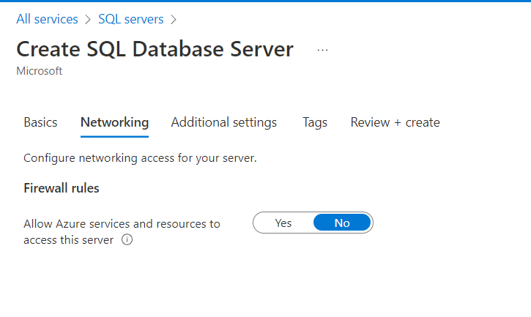
Afterwards, navigate to the Additional Settings page by clicking the tab at the top of the page or the button at the bottom of the page labelled as Additional Settings. On this page the following configurations will be applied:
- Microsoft Defender must be set at Not Now as the client did not explicitly state that they required it
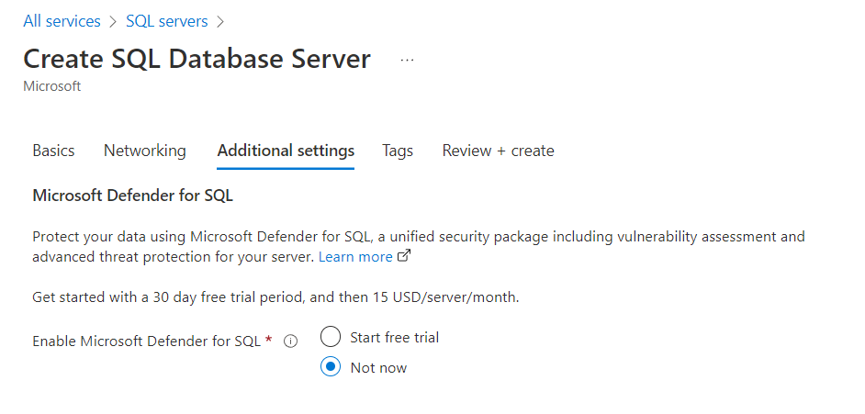

Afterwards, navigate to the Tags page by clicking the tab at the top of the page or the button at the bottom of the page labelled as Tags. On this page the following configurations will be applied:
- Relevant name/value pairs can be created if necessary, for this project this will be left as empty.
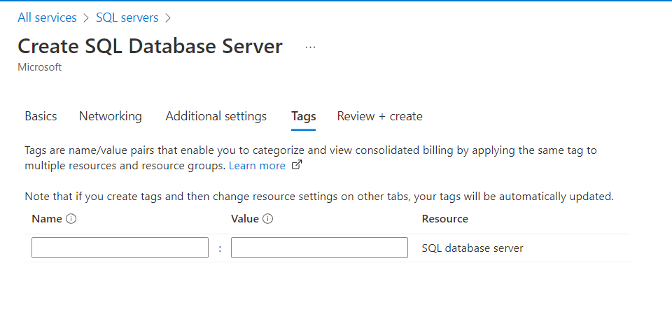
Next, navigate to the Review + Create page by clicking the tab at the top of the screen or the button at the bottom of the screen labelled as Review + Create. Make sure all details are correct and click Create on this page. Wait until the deploying in progress process is completed.
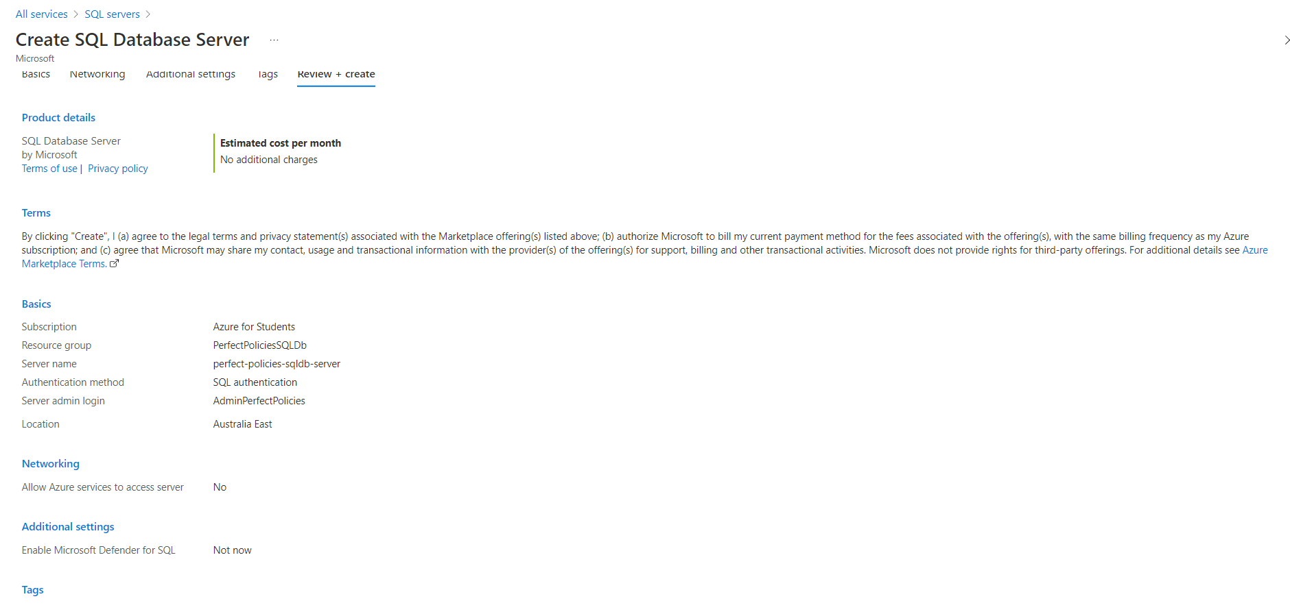
Once Your Deployment is Complete is presented, navigate to the newly created SQL server by clicking the Go To Resource button.
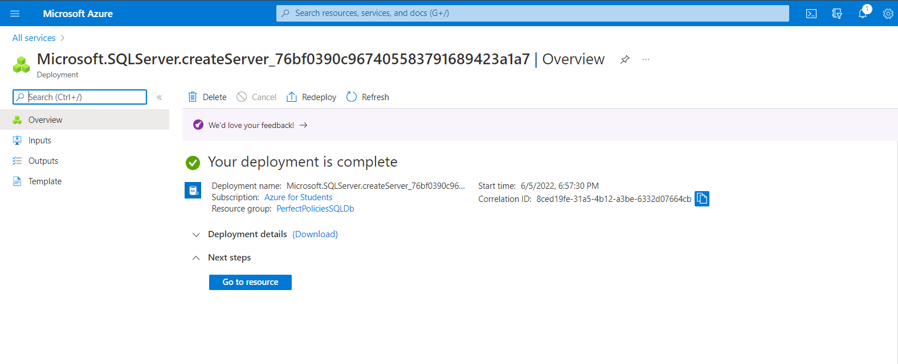
On this page, navigate to Networks by clicking the button of the same name on the left-side menu under Security. On this page the client’s IP and our IP address must be added. For the time being, only out IP Address will be added. To add out IP Address, click Add your client IPv4 address under firewall rules. Alongside this, under exceptions, tick the box for “Allow Azure services and resources to access this server”. Once completed, click Save to save settings.
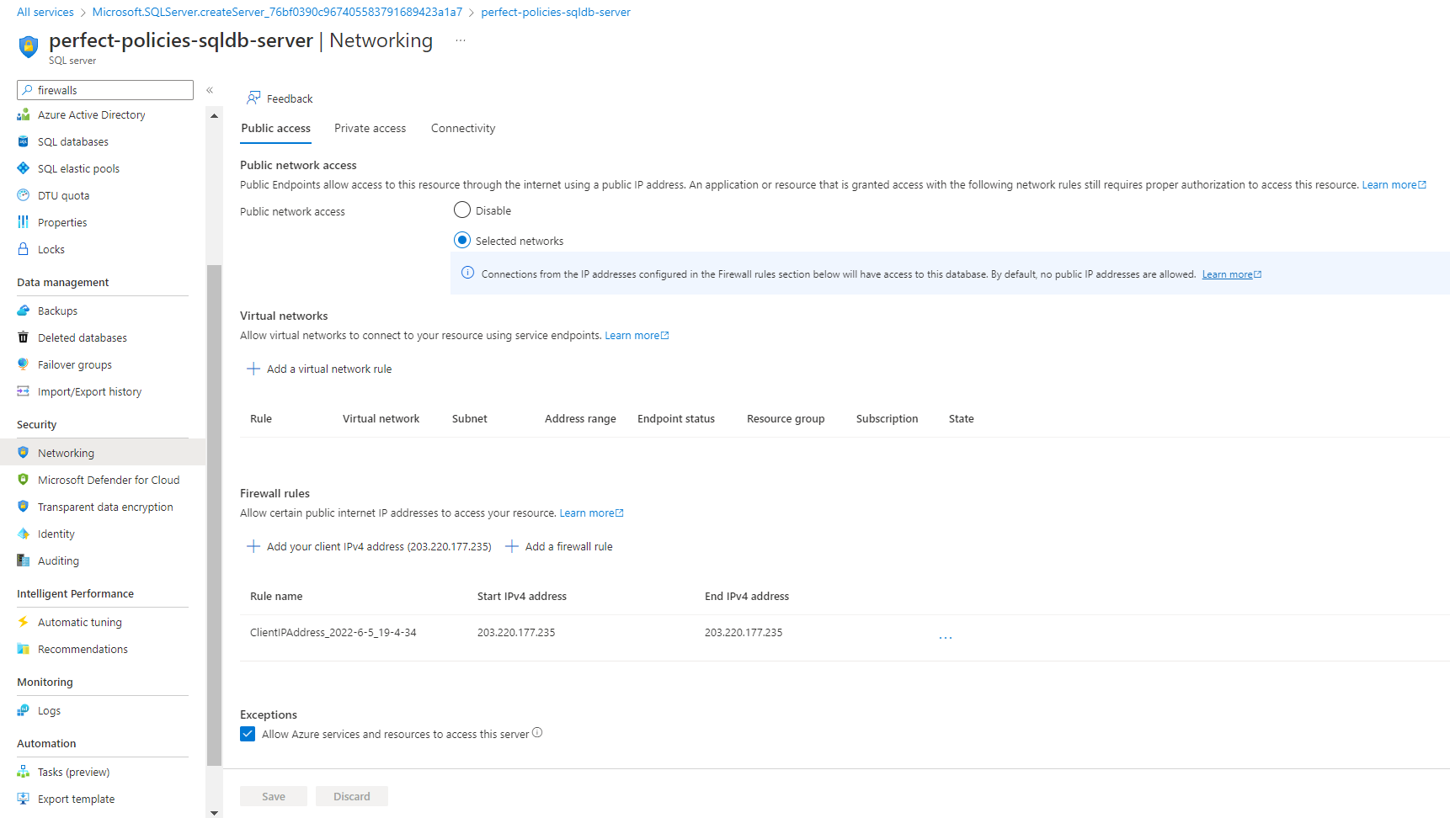

Navigate back to the SQL server overview page by clicking Overview on the menu on the left-hand side of the screen, and click Create Database at the top of the page.
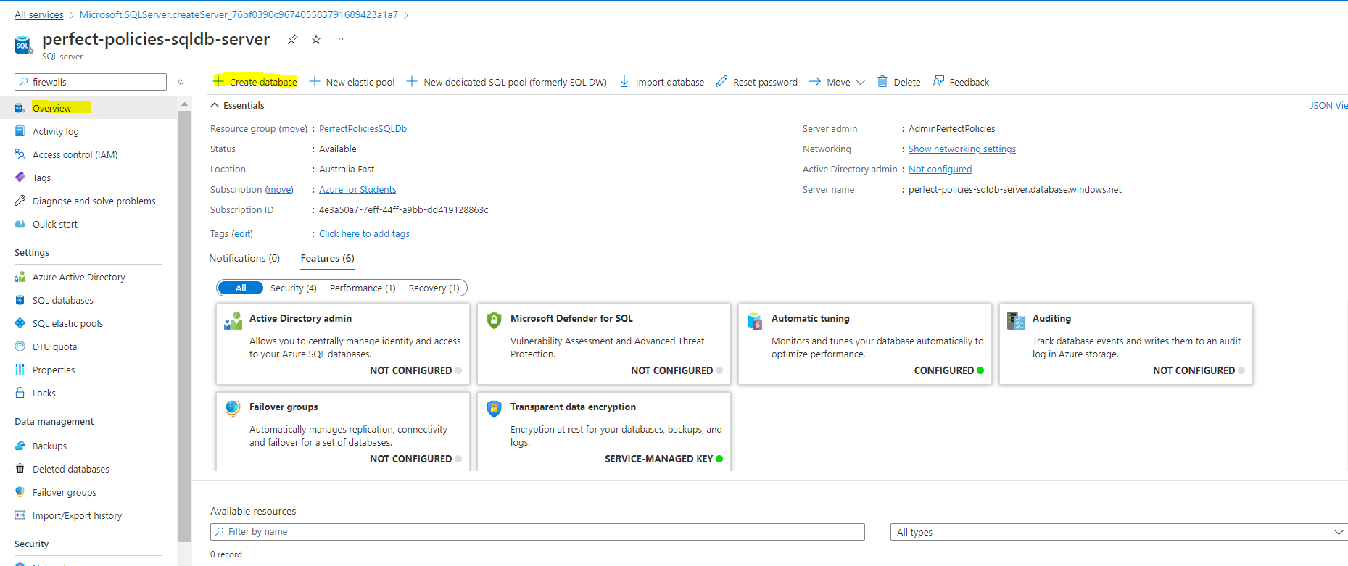

On the Basics Tab the following initial configurations must be applied:
- A database name that adheres to relevant naming conventions.
- The SQL Elastic Pool will be set to No
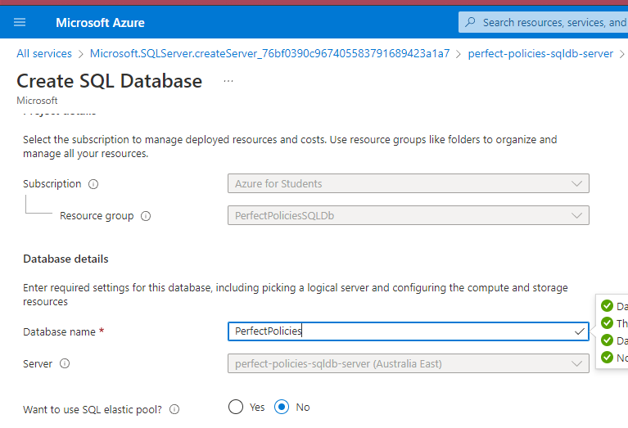
Afterwards click on configure database next to the Compute + Storage label. Set the service tier to Basic and Data max size to 2. Afterwards click the Apply button at the bottom of the page.
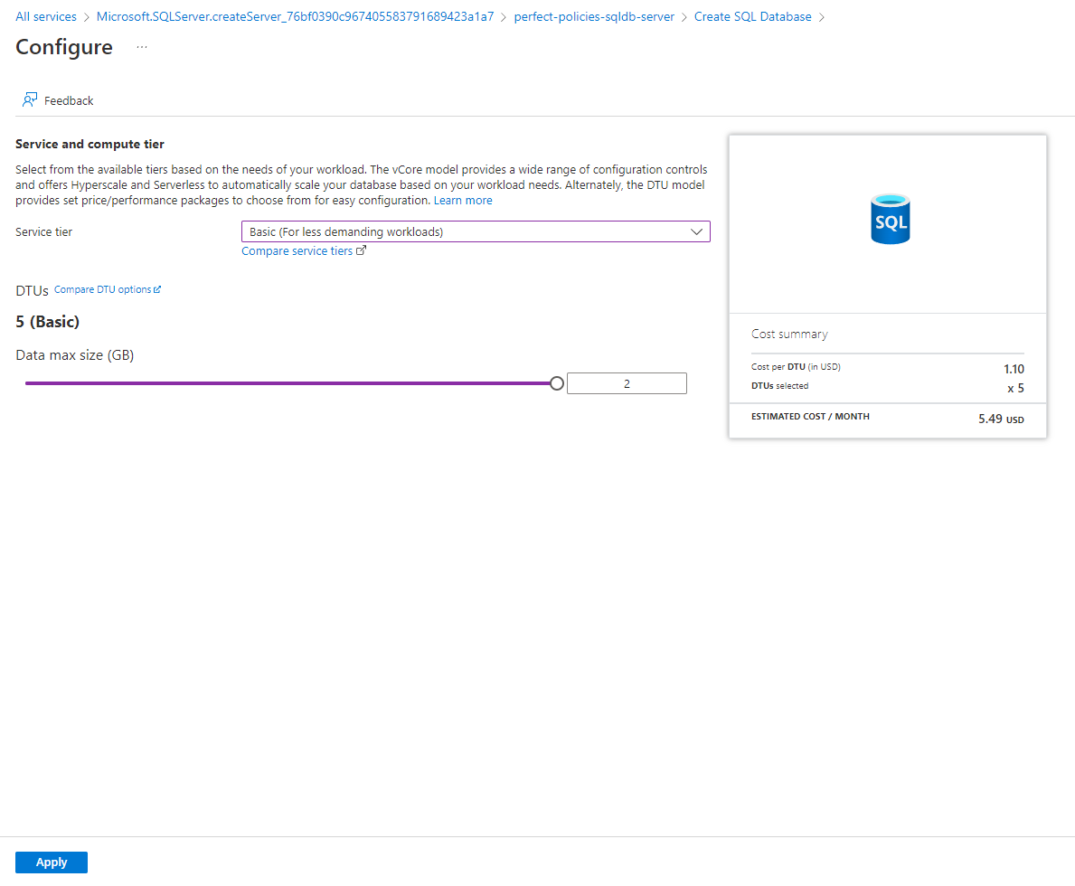
Back at the Basics page, for Backup storage redundancy select Locally-redundant backup storage.
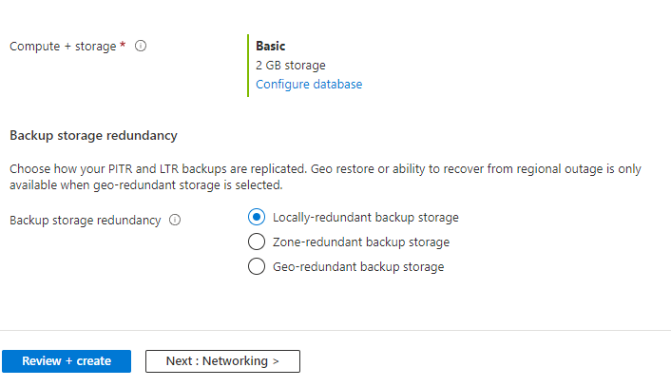
Next, navigate to the Networking page by clicking the tab at the top of the page or the button at the bottom of the page with the same name. Nothing will be modified on the Networking page, therefore, we can naviagte to the Secuirty page using the same navigation procedures.
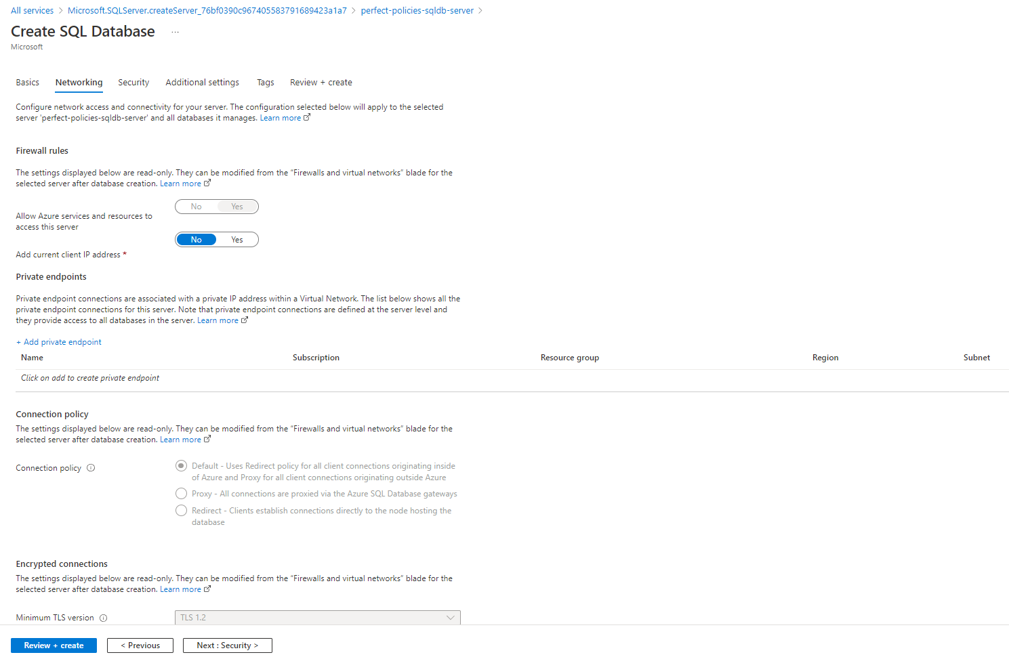
On the security tab nothing will be modified, therefore, we can navigate to the Additional Settings page by clicking the button at the bottom of the page or the tab at the top of the page with the same name.
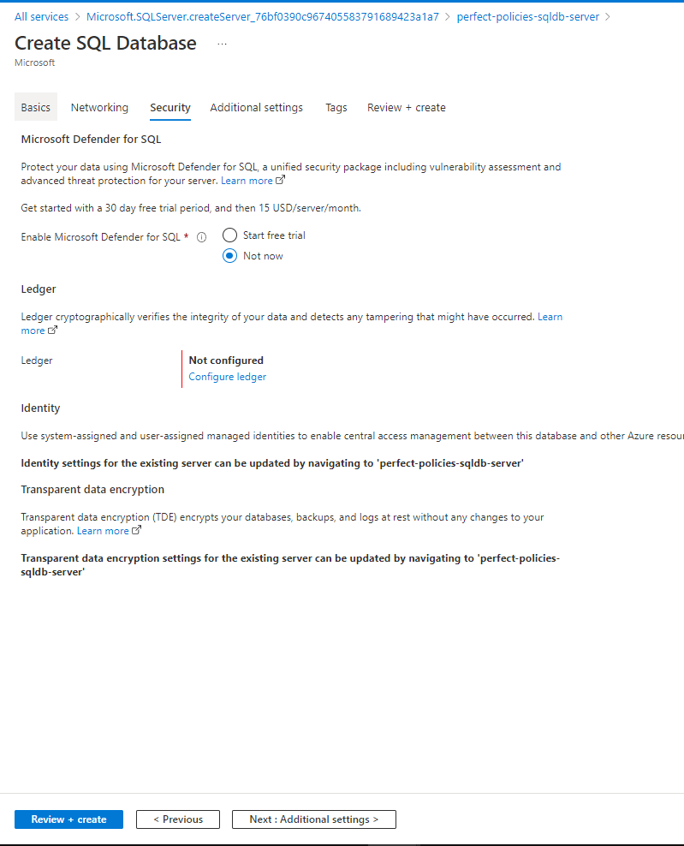
On the additional settings tab nothing will be modified, therefore, we can navigate to the Tags page by clicking the button at the bottom of the page or the tab at the top of the page with the same name.
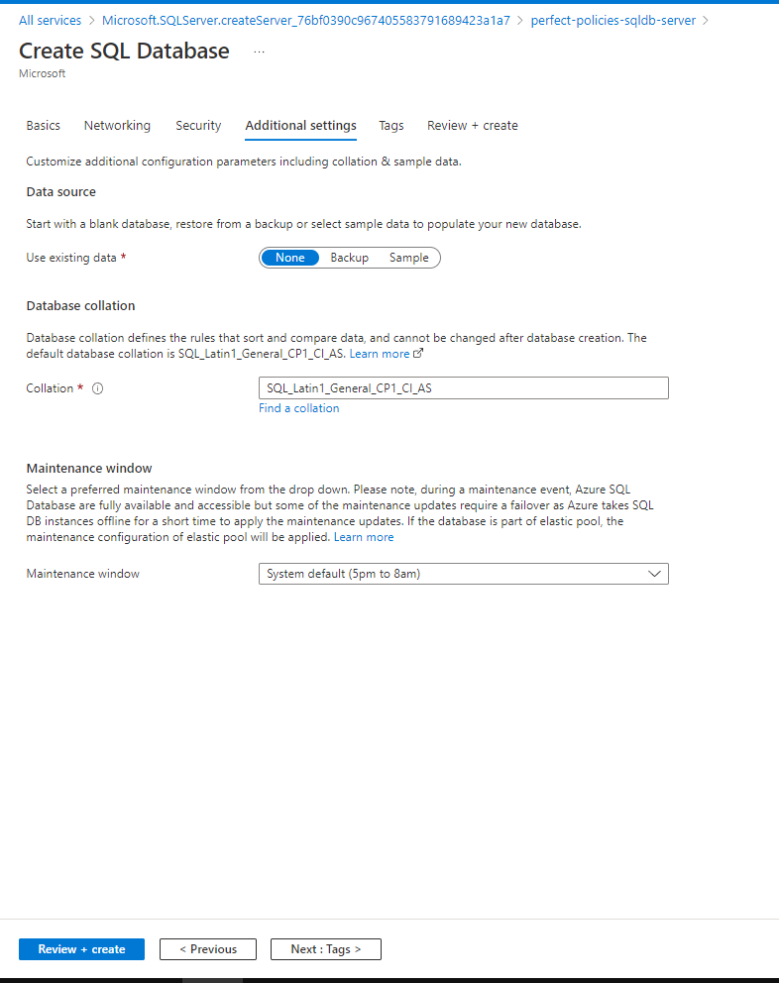
On the Tags tab nothing will be modified, therefore, we can navigate to the Review + Create page by clicking the button at the bottom of the page or the tab at the top of the page with the same name.
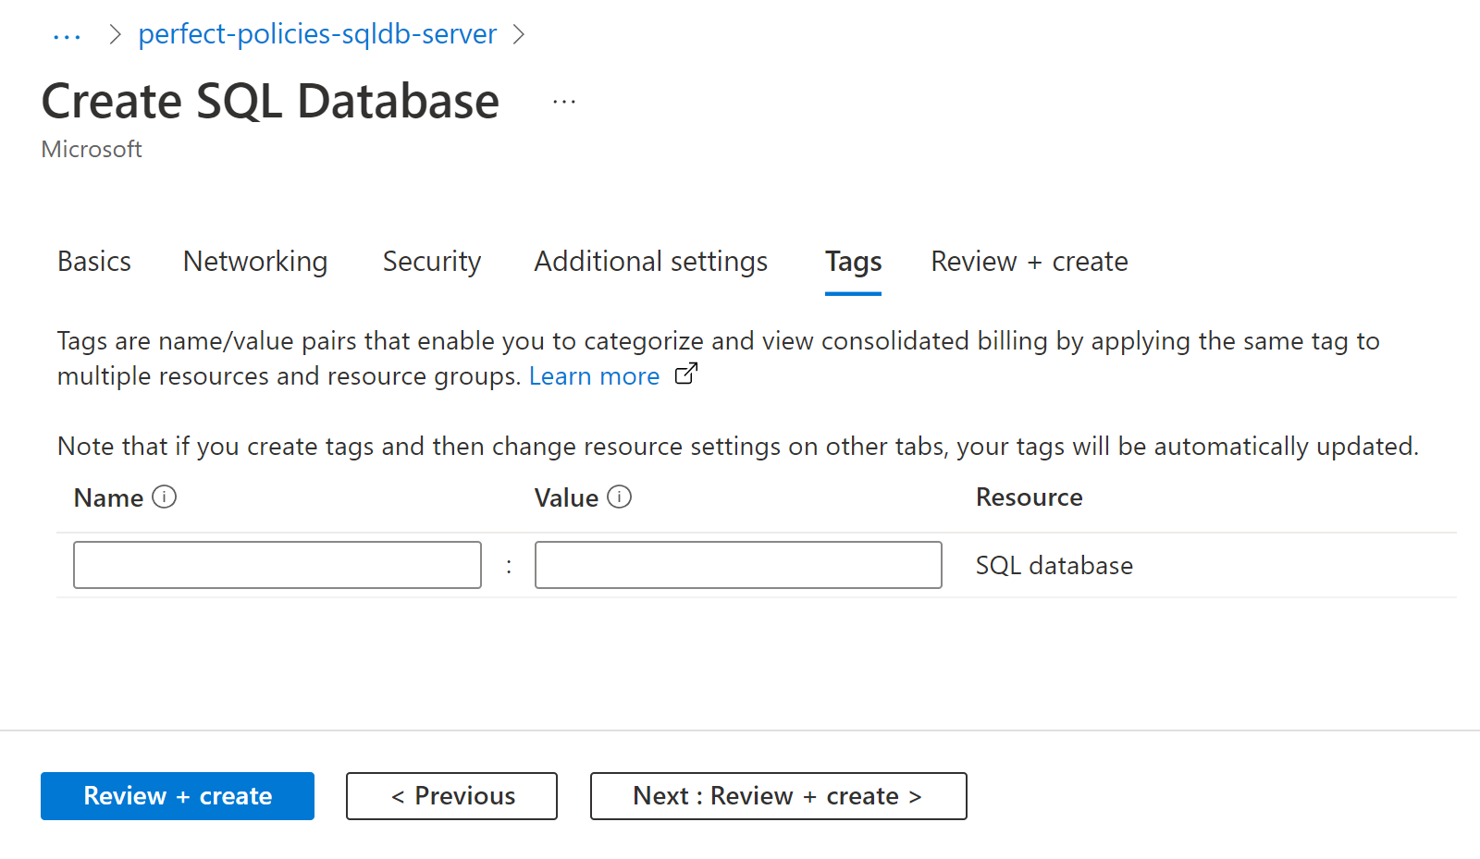

On the Review + Create page, review the details that they are correct and click the Create button to Create an SQL Database.
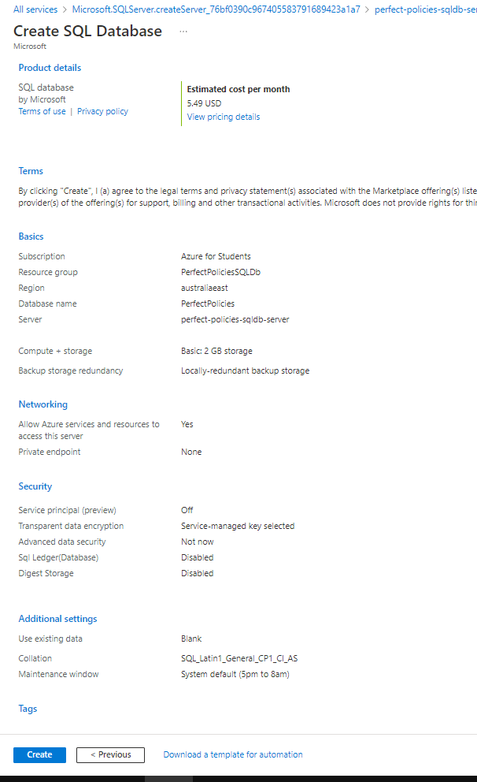
After Your deployment is complete is presented, click the Go to Resource button to navigate to the SQL Database.
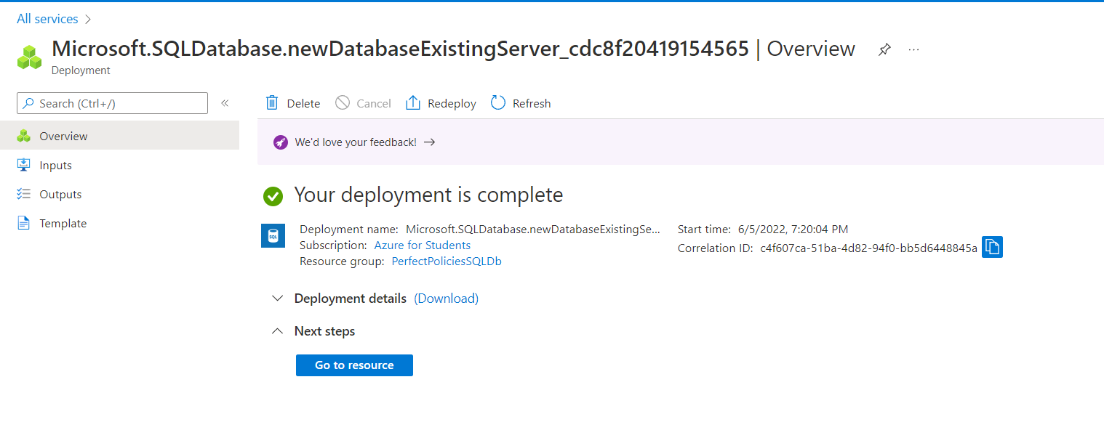
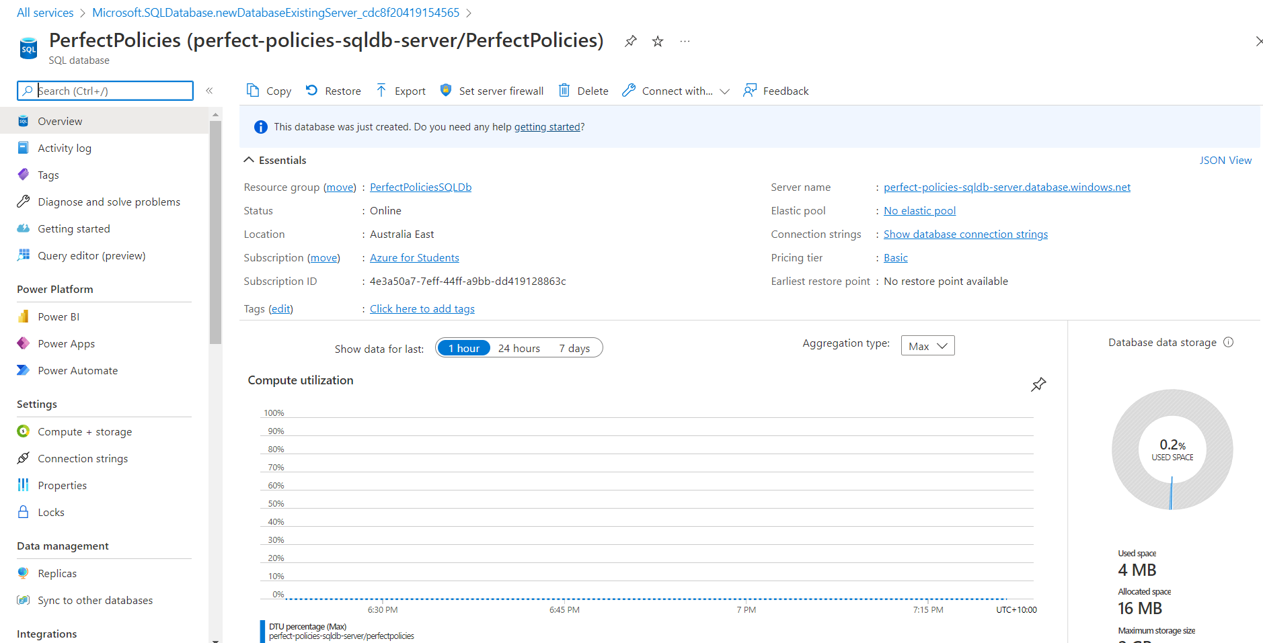

At this point deployment of the actual API can begin. Open the API Source Project Files in Visual Studio, Select Build and Publish.
On the Publish Page, select Azure and click Next. The Specific Target will be Azure App Service (Windows). Click Next and Sign in with Azure details.
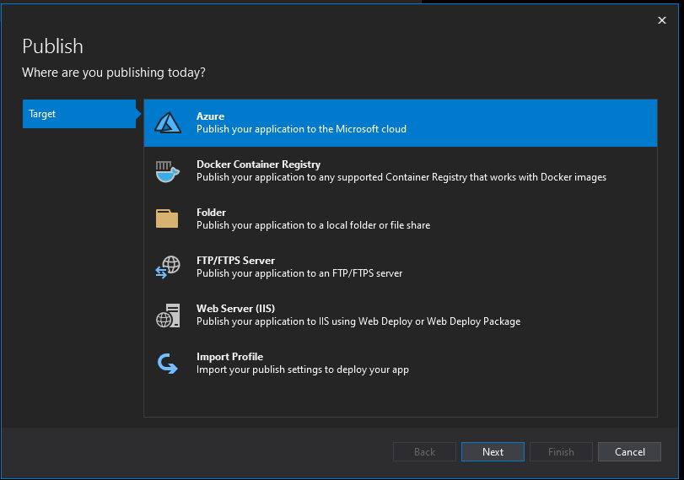
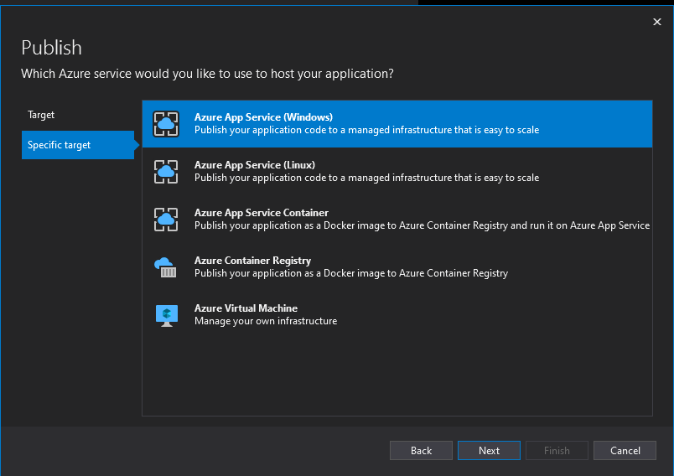
After logging in, in the App Service window click the + button to create a new App Service Instance.
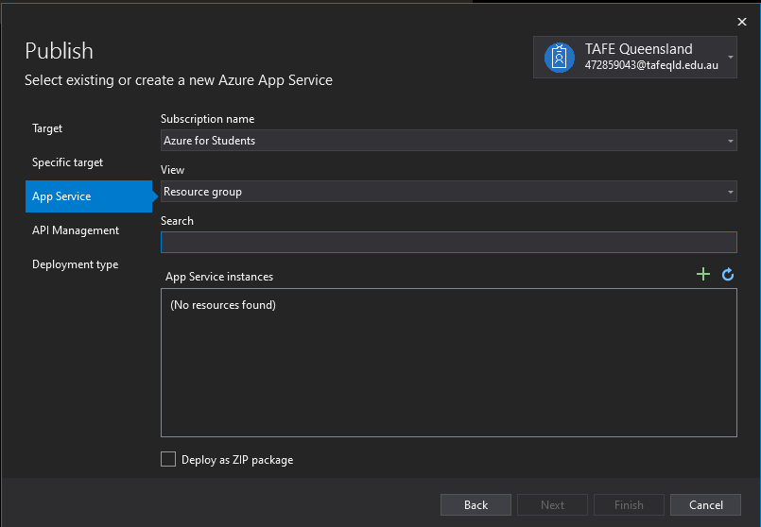

Set the following configurations for the App Service and the Hosting Plan in the configurations below. Click new to access the Hosting Plan Window.
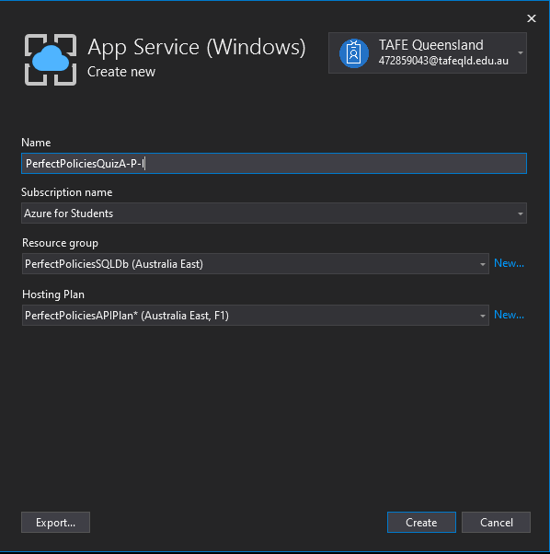
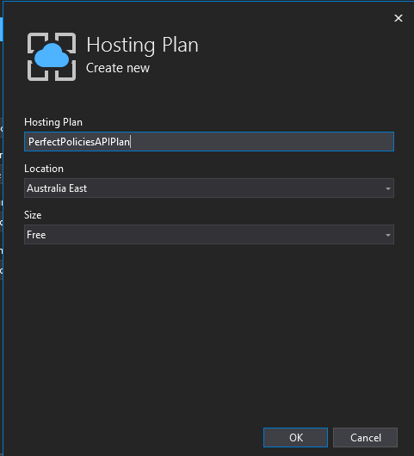
Next, click create. Wait until the app service creation process is finished. Select the newly created App Service instance and click Next.
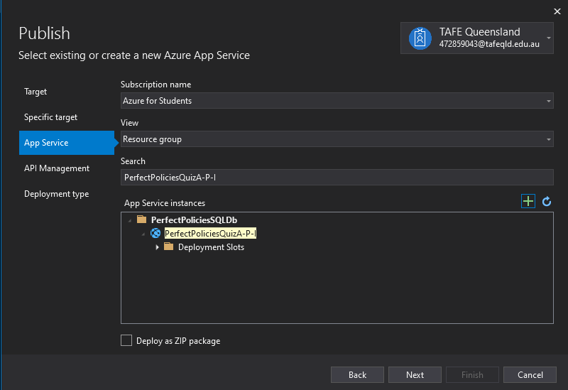

Tick the Skip this step box in the API management page. And Click Finish.
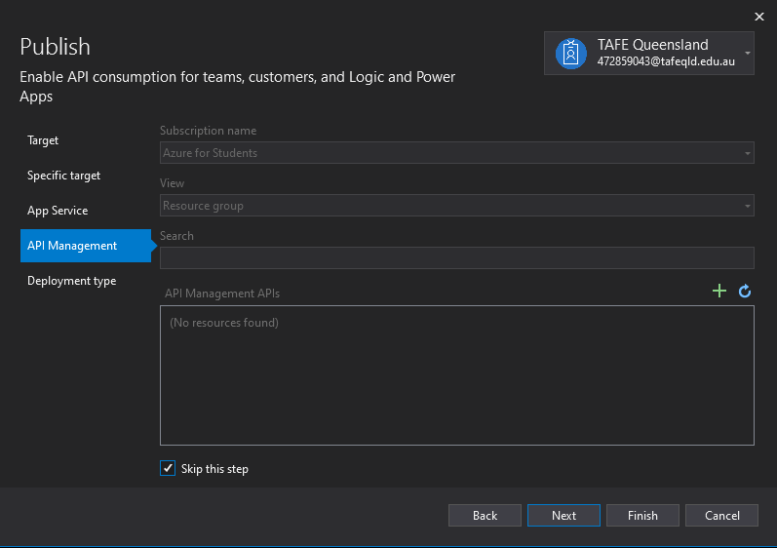
On the Publish Tab Click all settings and a new window should pop up. On this new window, change the target runtime to win-86 and click save. Afterwards, click Publish.
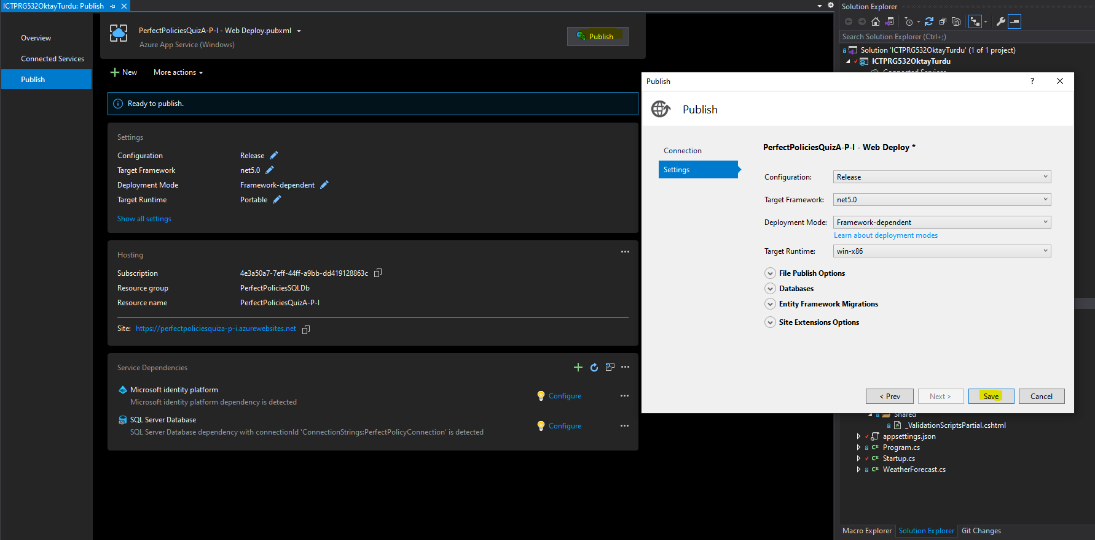
If the process is successful, a prompt with published date and time should appear. Click the three dots in the hosting section and select Open in Azure Portal.
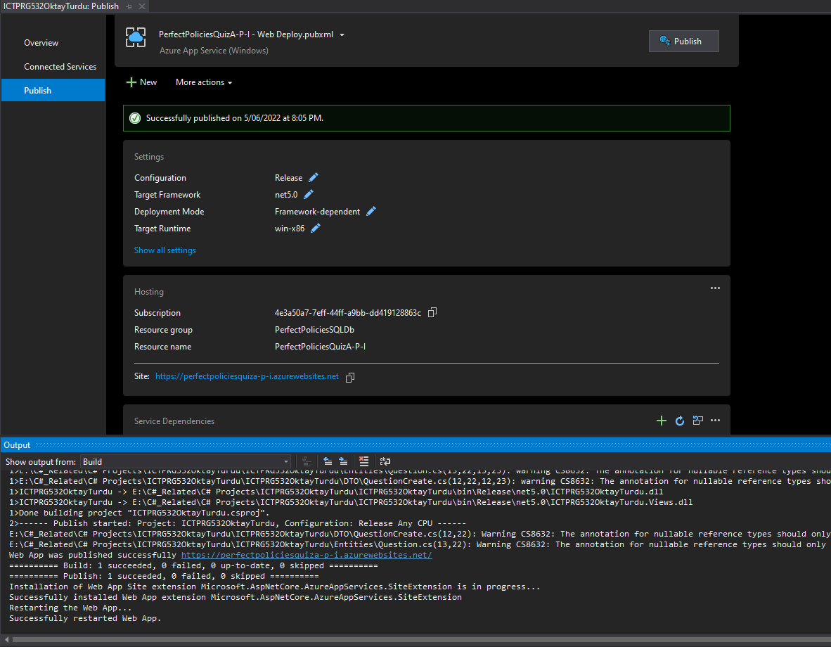
This will open the newly created App Service. From here, click Home, then click SQL Databases, and select your chosen database.
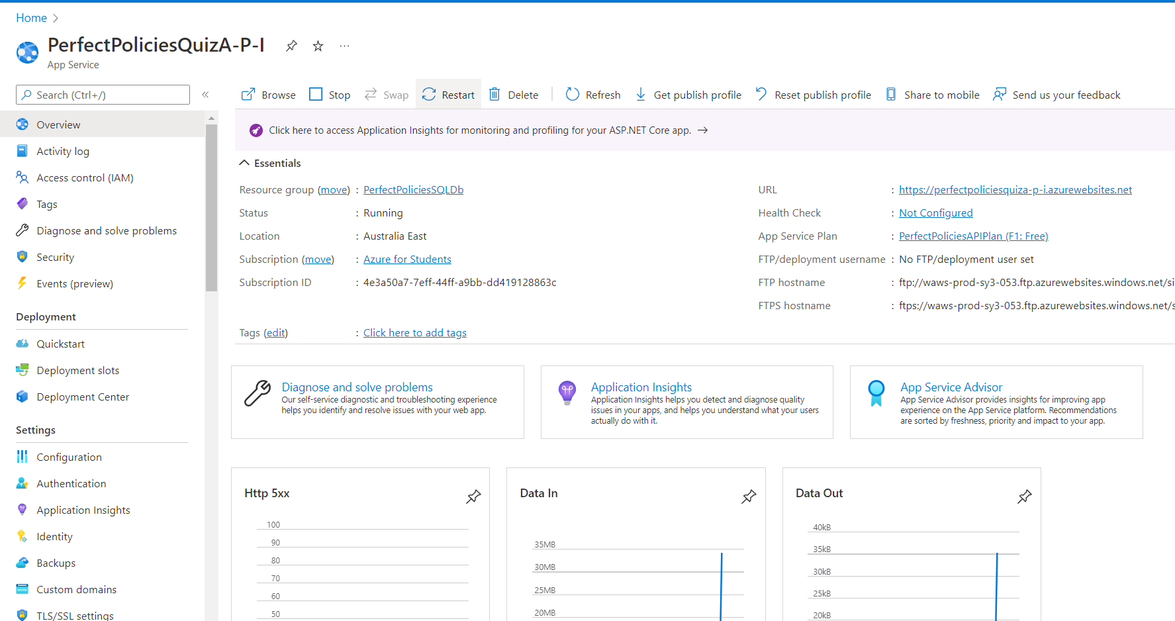

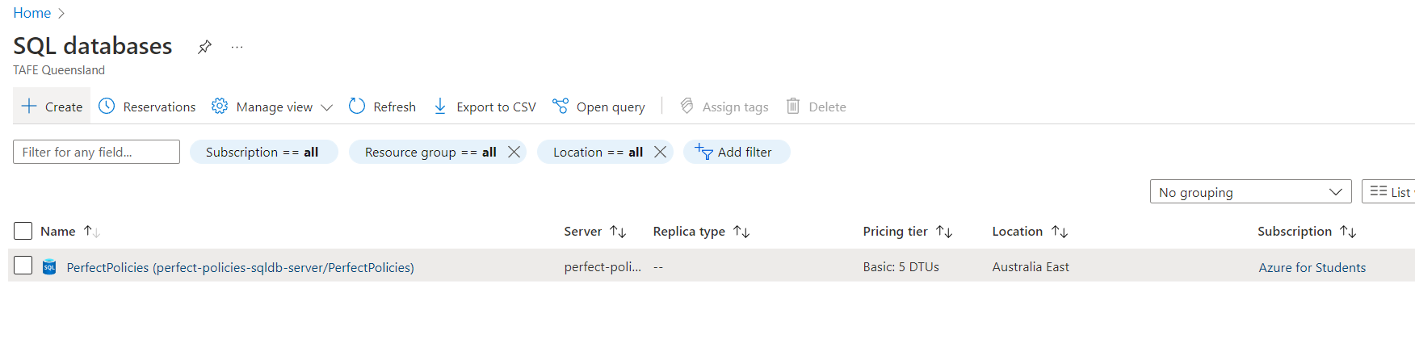
Click Show database connection strings and copy the string.
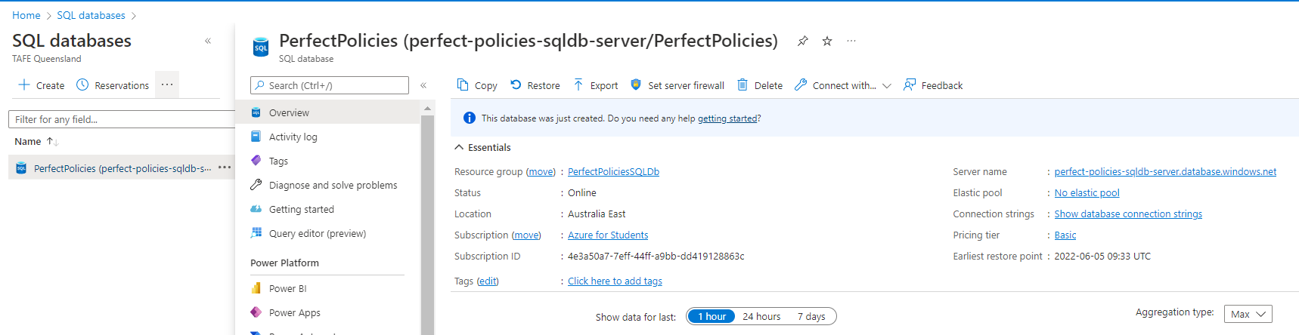
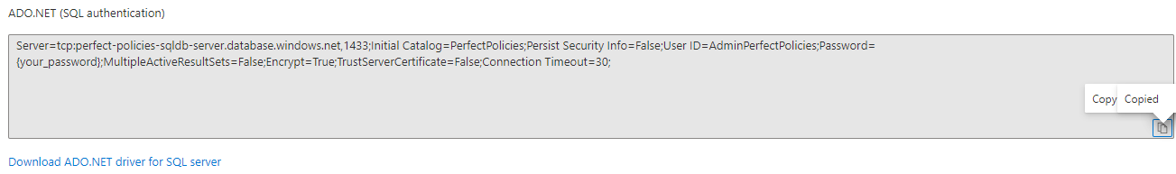
Navigate back to the newly created App Service and click Configuration from the menu on the left-hand side of the screen. Click New connection string and enter the following details:
- The Name will be the value in the appsettings.json file under ConnectionStrings in API source code files
- The Value will be the connection string that was copied from the Azure database (Add database password to this string manually)
- The Type will be SQLAzure
Click OK after these details are entered.

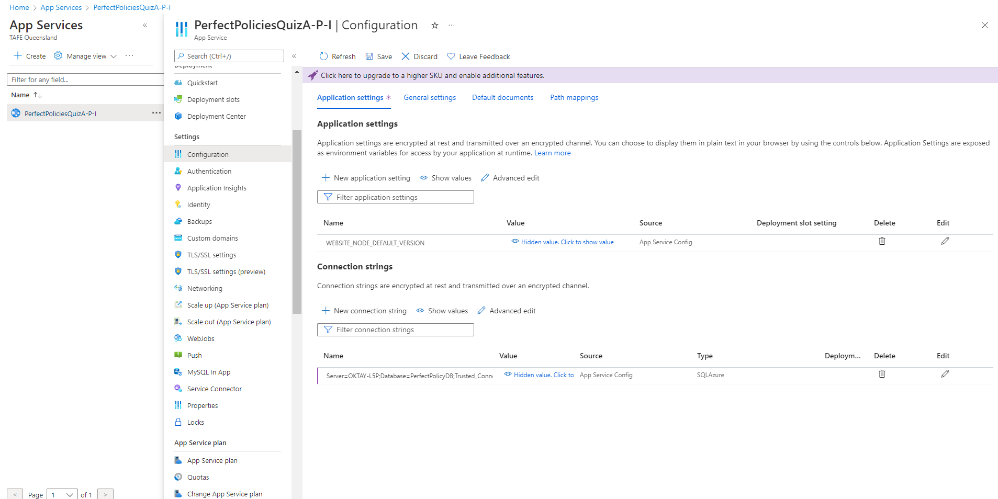

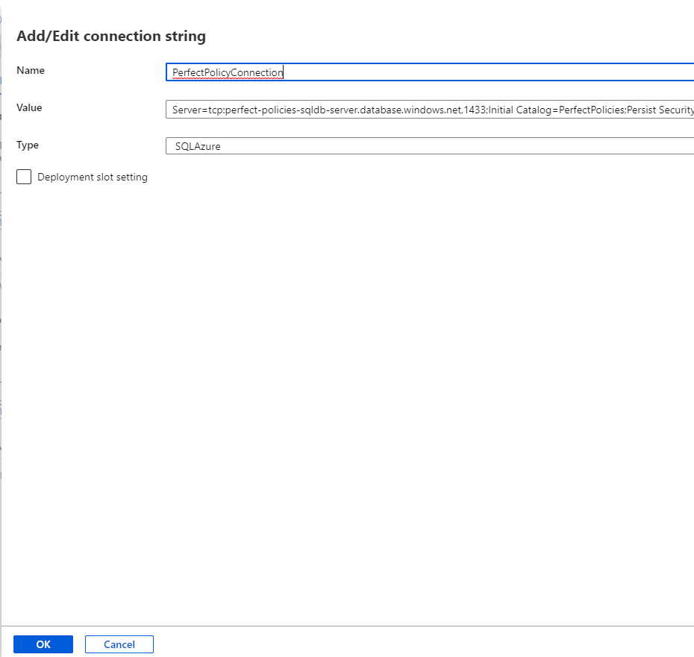

Next, navigate to the Configure method in the Startup.cs class in Visual Studio. Insert context.Database.Migrate(); to dependency inject context. This will migrate the initial migration to the Azure SQL database. Comment out the if statement around Swagger to test the API later. Finally Publish the API again.
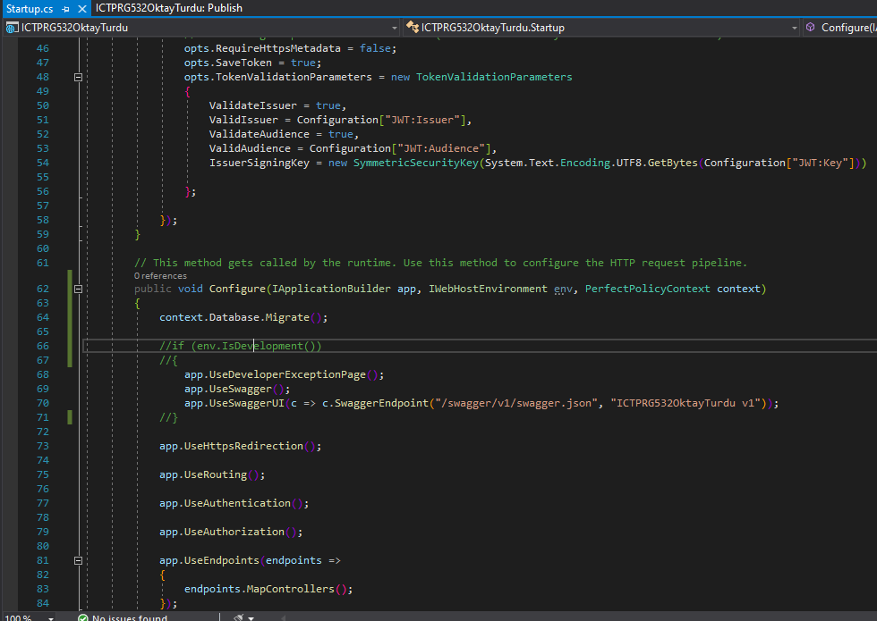
Open a web-browser and navigate to the web address of the API, for this project it will be as follows:
https://perfectpoliciesquiza-p-i.azurewebsites.net/swagger/index.html
Test the various functionalities and execute the endpoints to make sure they work as intended.
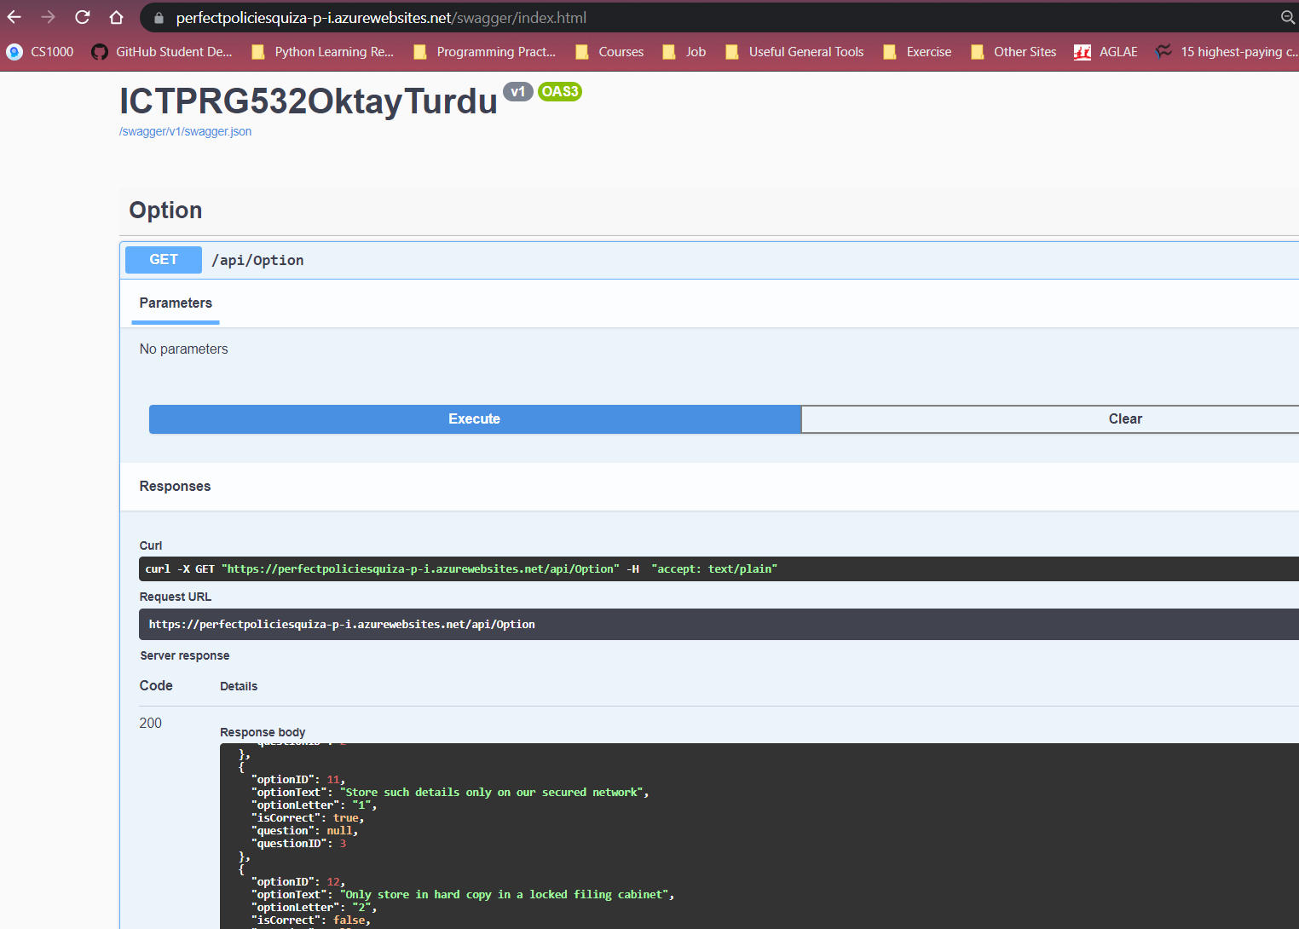

Post-Installation Tasks
Setting Up Connection Strings with User Roles and Permissions
Open SQL Server Management Studio and enter the following details:
Server Name: perfect-policies-sqldb-server.database.windows.net
Authentication: SQL Server Authentication
Login: AdminPerfectPolicies
Password: PerfectPolicies!22

Afterwards, click Connect.
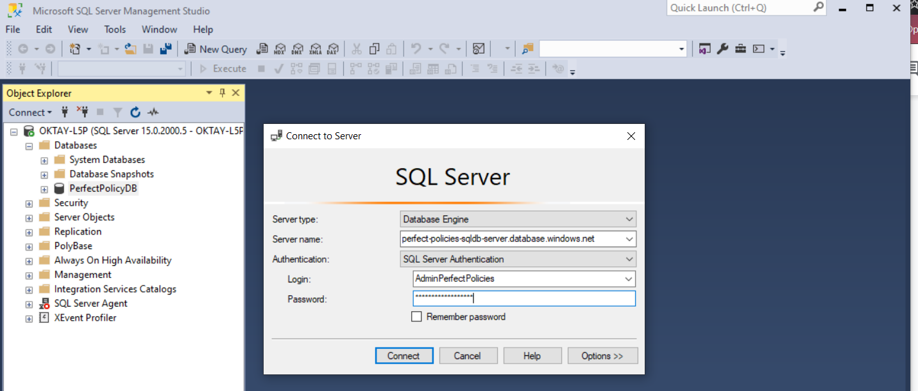
On the menu on the right-hand side, exapnd Security, right-click Logins and Click New Login.
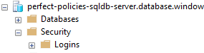
Replace <SQL_login_name, sysname, login_name> with an appropriate login name and replace <password, sysname, Change_Password> with an appropriate password. Then Click Execute. The following details will be used for this project:
Login: RestrictedUser
Password: Qwer_1234
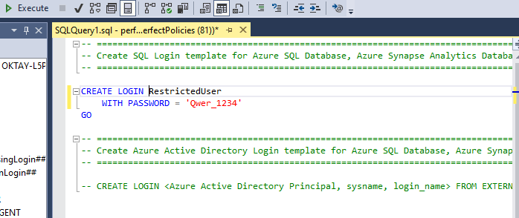
A new user with the provided details should be visible under Logins
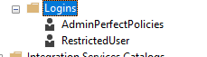

Expand Databases, expand the PerfectPolicies database, expand Security, and right-click on Users and select New User.
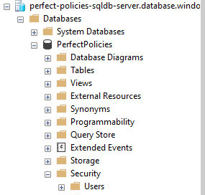

On the SQL Query Page, replace <user_name, sysname, user_name> with an appropriate username, and replace <login_name, sysname, login_name> with the newly created login. Replace <default_schema, sysname, dbo> with an appropriate Schema.
User: RestrictedUser
Login: RestrictedUser
Schema: dbo
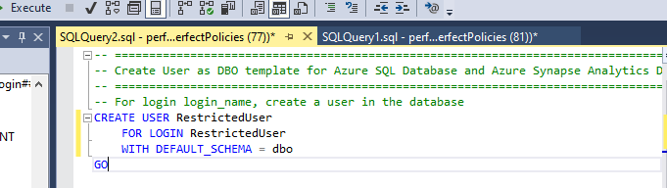

Set the roles to the member by replacing the following: EXEC sp_addrolemember N'db_owner', N'<user_name, sysname, user_name>' with the appropriate SQL query string.
EXEC sp_addrolemember N'db_datareader', @membername = N'RestrictedUser'
EXEC sp_addrolemember N'db_datawriter', @membername = N'RestrictedUser'
Afterwards, click Execute. If successful a new user should be created under Users.
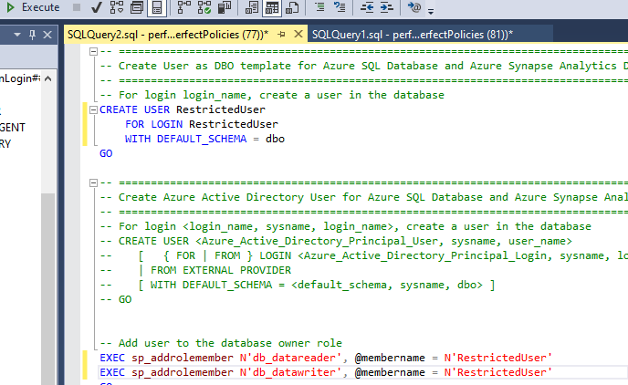
Log-in to Azure and navigate to App Services. Select the API, and click Configuration on the right-hand side menu.
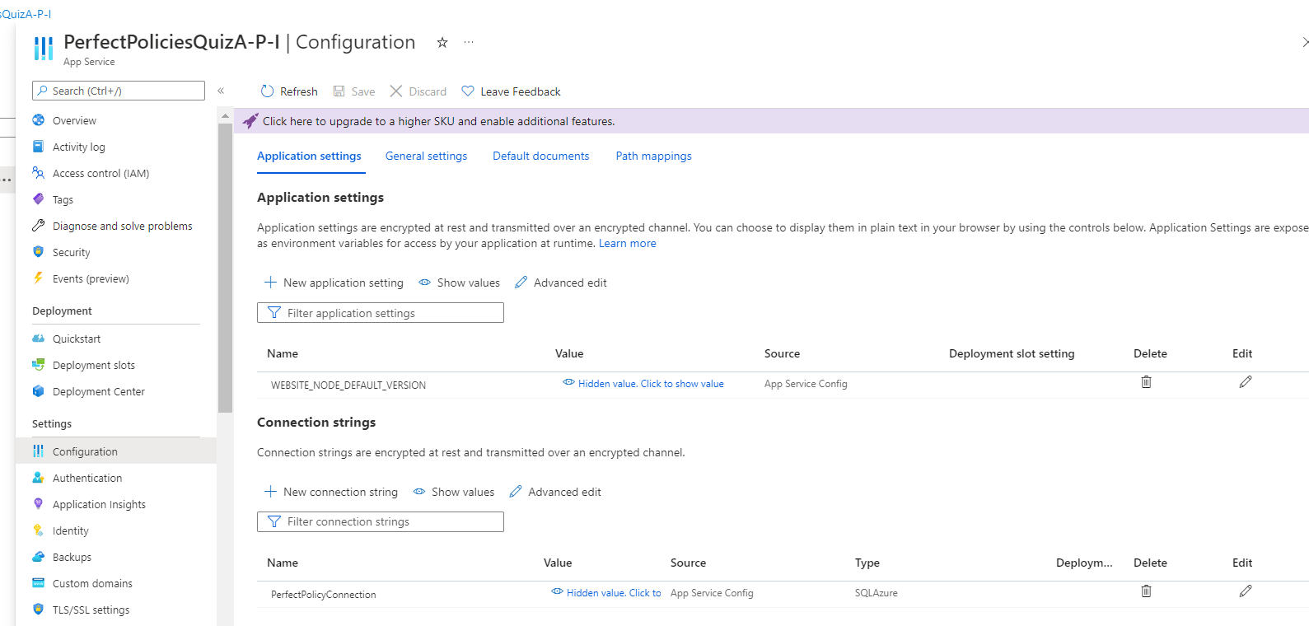
Under Connection strings, click Advanced edit. In the value section replace User ID and Password with the user details utilized when creating the user.
RestrictedUser
Qwer_1234
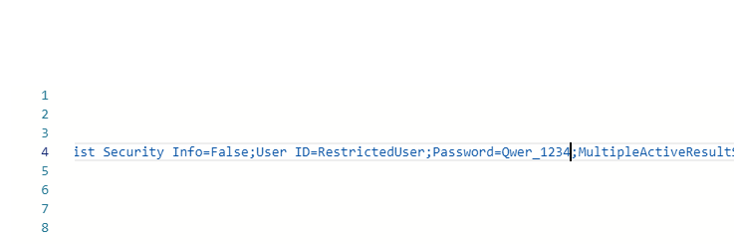
Click OK and Save. Test that the API still connects.
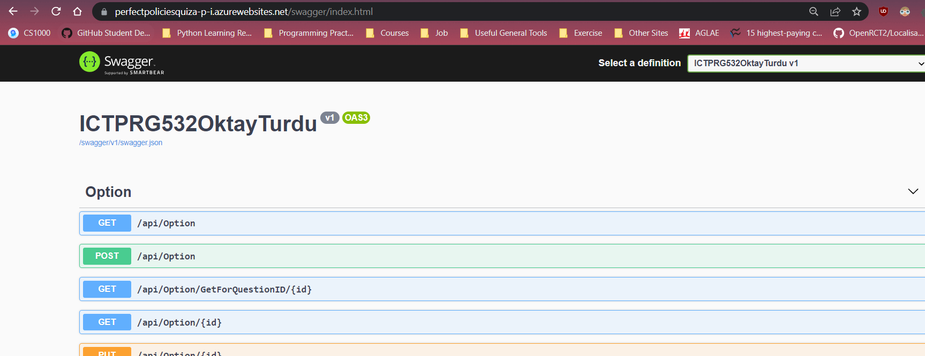

Backup Procedure
The general backup procedure is outlined below, however, it is important to note that the frequency of backups will be up to the client’s discretion. Backups will be saved on an external hard drive.
Log-in to Azure and navigate to SQL databases. Click the database you intend to backup.
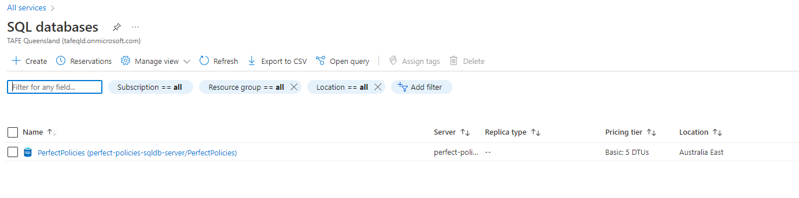
Click the Export button at the top of the page. Input various configuration details if necessary. For this project all of these will be the default value. Provide the admin login and password:
For this project the following details were inputted:
Storage: PerfectPoliciesBackUp
Login: AdminPerfectPolicies
Password: PerfectPolicies!22
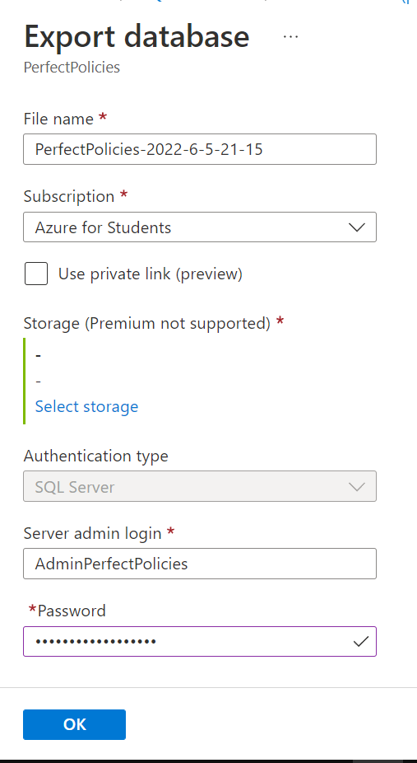
Click OK, once complete the Backup will be able to be downloaded as per Company policy and procedures. The API will be saved in a private GitHub repository as well as on company servers.
Updates
Before an update occurs the application and all related functionalities must be backed up. After this software updates can be published to Azure in accordance with the Installation Guide in this document.

Uninstallation Procedure
To uninstall any application from Azure the following steps must be undertaken:
Log-in to Azure and Click on the More Services button on the home page. Click Database and Click SQL Databases to delete an SQL Database.
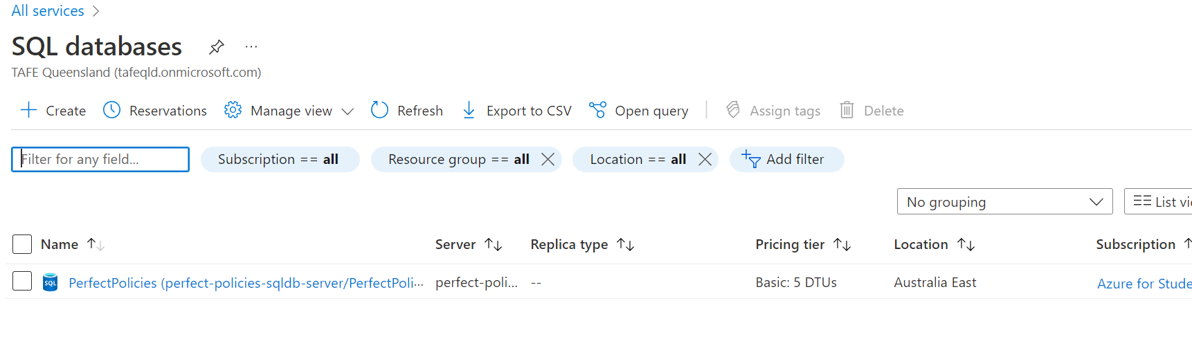
Click the SQL Database you intend to delete. And Click the Delete button at the top of the page.
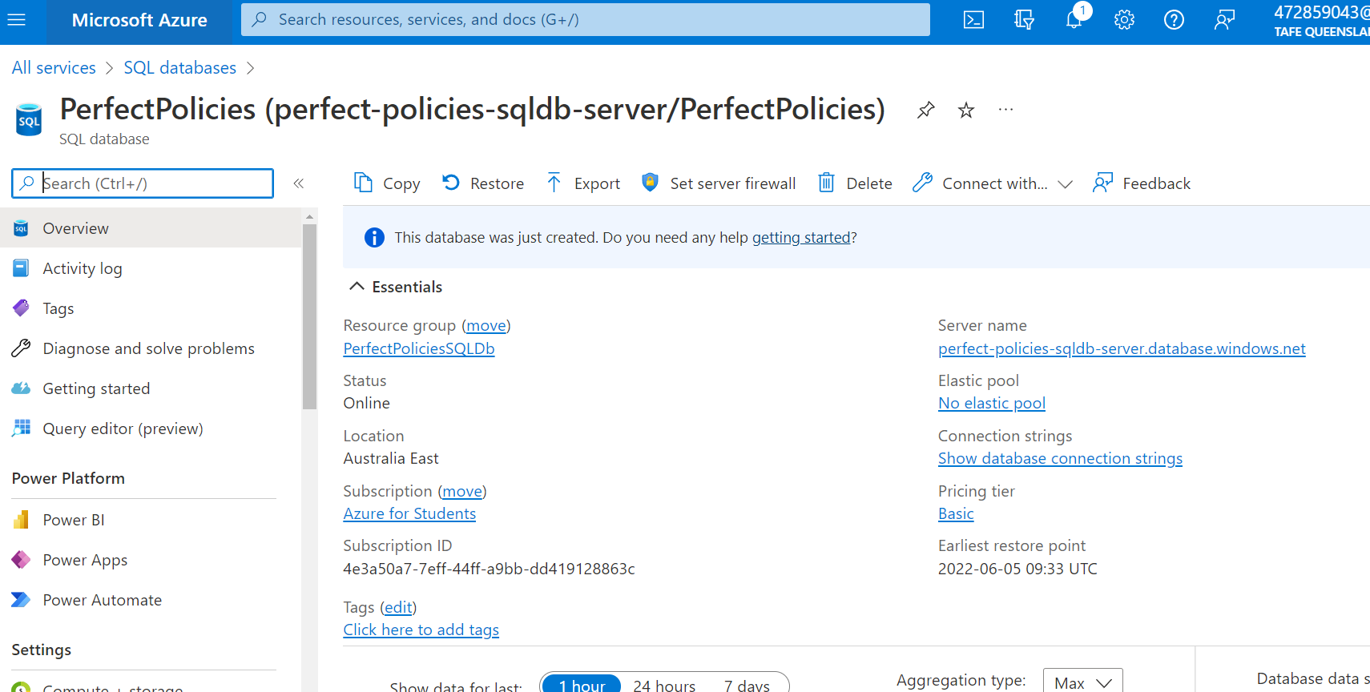
To delete an App Service, navigate to the App Services page and click the App Service you intend to delete.
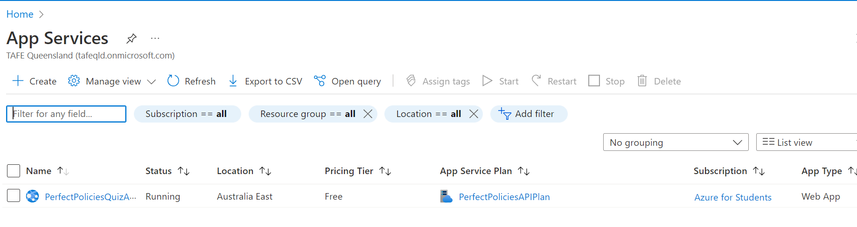
Click the App Service you intend to delete. And Click the Delete button at the top of the page.
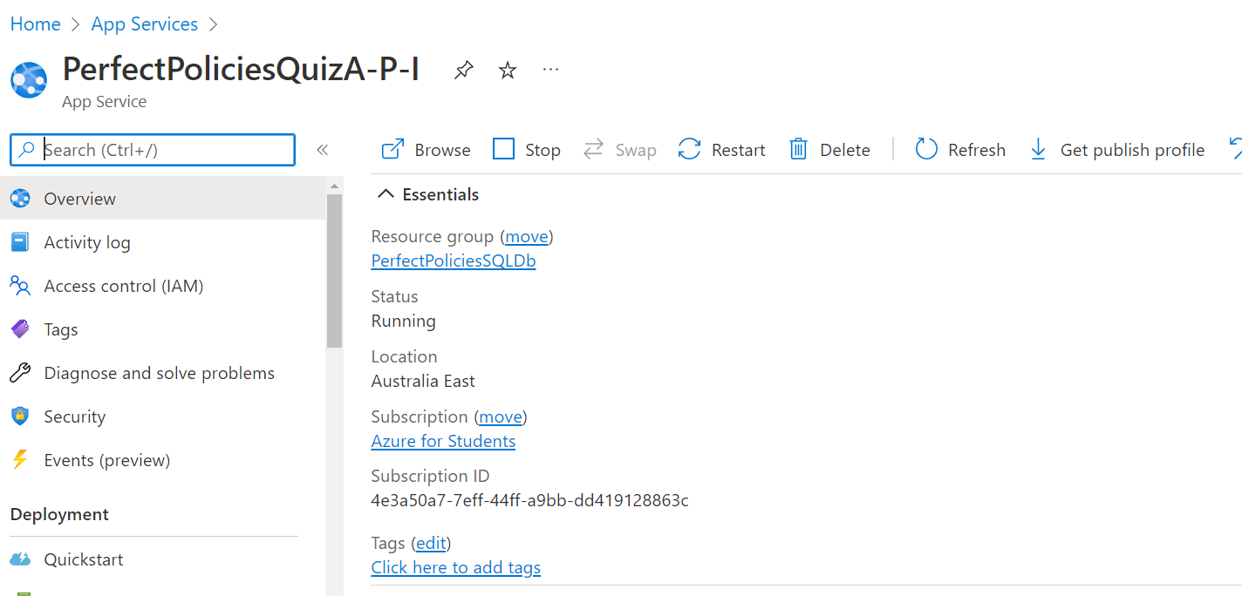

Sign-Off
Project Name: | Perfect Policies
Project Manager: | Shaun O’Sullivan
Start Date: | 3/06/2022
Completion Date: | 5/06/2022
Project Deliverables:
Technical Report
Software Installation Plan
ICTPRG532 Backend Source Files – Deployed to Azure Alongside Database
ICTPRG532 Front End Source Files
Business Case Scenario and Programming Guidelines
I acknowledge that I have submitted all the stated deliverables as per the Project Requirements and your instructions.
Oktay Turdu
Programmer’s Name | Signature | Date
Shaun O’Sullivan
Project Manager | Signature | Date

